Aerobic Rice

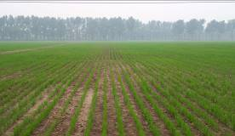
What is Aerobic Rice?
A dry seeded aerobic rice field
Aerobic rice is a production system in which especially developed “aerobic rice” varieties are grown in well-drained, non-puddled, and non-saturated soils. With appropriate management, the system aims for yields of at least 4-6 tons per hectare. See also “http://www.irri.org/Aerobic_Rice” for more information.

Target area
Aerobic rice can be found, or can be a suitable technology, in the following areas:
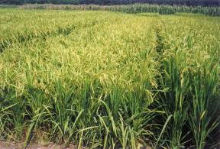
- “Favorable uplands”: areas where the land is flat, where rainfall with or without supplemental irrigation is sufficient to frequently bring the soil water content close to field capacity, and where farmers have access to external inputs such as fertilizers.
A ripening aerobic rice field
- Fields on upper slopes or terraces in undulating, rainfed lowlands. Quite often, soils in these areas are relatively coarse-textured and well-drained, so that ponding of water occurs only briefly or not at all during the growing season.
- Water-short irrigated lowlands: areas where farmers do not have access to sufficient water anymore to keep rice fields flooded for a substantial period of time.

Management
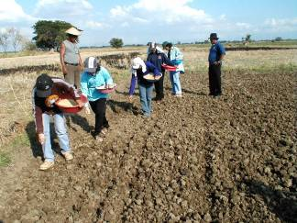
The usual establishment method is dry direct seeding. Aerobic rice also allows practices of conservation agriculture as used in upland crops, such as mulching and minimum tillage.
Dibbling aerobic rice seeds

Aerobic rice can be rainfed or irrigated. Irrigation can be applied through flash-flooding, furrow irrigation (or raised beds), or sprinklers.

Unlike flooded rice, irrigation—when applied—is not used to flood the soil but to just bring the soil water content in the root zone up to field capacity.

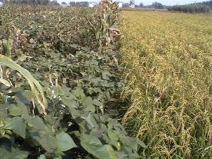
Site-specific nutrient management (SSNM; www.irri.org/irric/ssnm) can be used to determine the optimal management of fertilizers. In the absence of knowledge on SSNM, 70-90 kg N ha⁻¹ could be a useful starting point to obtain a yield of 4-6 t ha⁻¹. The first split can best be given 10-12 days after emergence, the second at active tillering, and the third at panicle initiation. The application of fertilizer P can be more critical for aerobic rice than for flooded rice.
Aerobic rice growing
side by side with soy bean

Rice fields that are not permanently flooded tend to experience more weed growth and more species of weeds. Appropriate herbicide use, plus additional manual or mechanical weeding in the early phases of crop growth, is therefore needed to control weeds.

Soil-borne pests and diseases such as nematodes, root aphids, and fungi are known to occur more in aerobic rice than in flooded rice, especially in the tropics. It is recommended to grow aerobic rice in rotation with upland crops suitable in the area.

Developed with input from: B.A.M. Bouman and R. M. Lampayan

Find Out More about Aerobic Rice:
Send an email to: b.bouman@cgiar.org or r.lampayan@cgiar.org.
Visit http://www.irri.org/Aerobic_Rice
Download the book “Water management in irrigated rice -
Coping with water scarcity” at: http://books.irri.org/9789712202193_content.pdf
or at: http://www.irri.org/publications/techbulletin/tech.asp?id=10

